ORACLE
Development Roadmap
From Foundation to Flagship
NQ / MNQ Micro E-Mini Nasdaq-100 Futures
TradingView Pine Script v5 · 1-Minute Chart
Current version: v1.5 (Live) · April 2026

PURPOSE | This document provides a complete overview of the Oracle strategy development roadmap — from initial build through to the v1.7 flagship version and beyond. It is intended for use by traders, developers, and stakeholders involved in the Oracle project.

1 Roadmap Overview
Oracle has been developed across six version milestones from initial proof-of-concept through to the planned v1.7 flagship release. Each version builds directly on the evidence collected from the previous version's live forward test and backtest data.

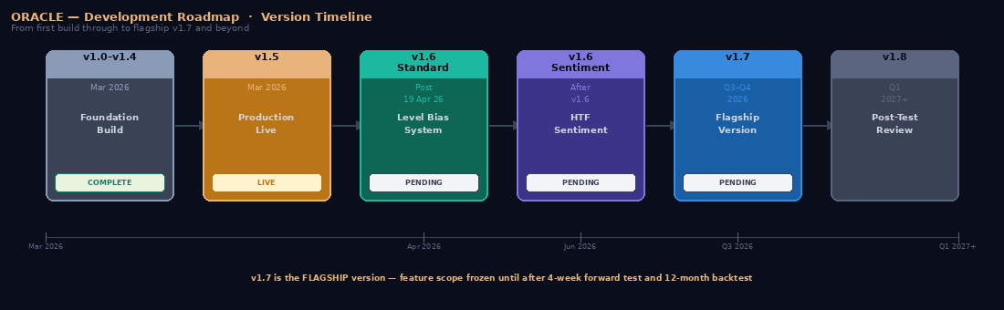

CORE PRINCIPLE | No version begins until all prerequisites for that version are confirmed and documented. Every change to Oracle is driven by live market data — not assumptions. This discipline is the reason the strategy has improved consistently across each version.

1.1 Version status summary
Version | Status | Timeline | Primary focus
v1.0–v1.4 | COMPLETE | Mar 2026 | Foundation build — key levels, 6 signals, risk management, P&L tracking, execution alerts
v1.5 | LIVE | Mar–Apr 2026 | Final production version — tick-level execution, timezone fix, session P&L attribution
v1.6 Standard | PENDING | Post 19 Apr 2026 | Level bias system — rejection/retest/flip model, dynamic R:R, 18-item update list
v1.6 Sentiment | PENDING | After v1.6 | Higher timeframe sentiment indicator — 5m/15m/30m/1H/2H/3H/4H/Daily selectable
v1.7 | PENDING | Q3–Q4 2026 | FLAGSHIP — Three Session merge, Asian/London ranges, FVG, multi-timeframe, visual aids
v1.8 | FUTURE | Q1 2027+ | Post-test review — additions, changes, removals based on v1.7 live data

2 v1.0 — v1.4 Development Versions
v1.0–v1.4  March 2026  COMPLETE | Foundation Build — Five iterative development versions establishing all core features  Scripts: Oracle_Basic/Pro/Master v1.0–v1.4

Versions 1.0 through 1.4 were the development phase — five rapid iterations establishing every core feature of the strategy. No formal backtests were run during this phase. The focus was building the complete feature set before optimising.

Version | Tag | Key features added
v1.0 | Original | Key level drawing (PDH/PDL/PWH/PWL/PMH/PML/Prev Friday Close), 6 candlestick signal types, fixed and trailing SL, basic dashboard table, daily P&L limits
v1.1 | Risk Additions | ATR dynamic SL, Breakeven move, Partial close (TP1/TP2), Re-entry block, Win streak lock-in, Consecutive loss alert
v1.2 | Signal Improvements | EMA trend filter, Volume filter, Friday Close directional bias, Signal spacing, London and NY session loss limits
v1.3 | P&L Tracking | Monthly P&L tracker, Annual target tracker, Contract calculator, Reload-safe weekly/monthly/annual scan functions
v1.4 | Execution | Execution alerts (PineConnector integration), News blackout window, R:R ratio in dashboard, Streak tracking

3 v1.5 Current Production Version
v1.5  4-week forward test ending 19 Apr 2026  LIVE — 22 Mar 2026 | Final production version — all critical bugs fixed, three-tier script structure introduced  Scripts: Oracle_Basic_v1.5 · Oracle_Pro_v1.5 · Oracle_Master_v1.5

3.1 What was fixed in v1.5
Fix | Detail
Tick-level SL execution | Added close_entries_rule='ANY' and calc_on_every_tick=true. SL now closes intra-bar at the stop price rather than waiting for bar close.
isToday timezone fix | todayYear/Month/Day now use sessionTZ consistently. Previously used CME Chicago time causing London session signals to appear as yesterday.
Session P&L attribution | London and NY P&L tracked incrementally on each bar. Old approach showed identical figures for both sessions.
Weekly P&L reload survival | Weekly/monthly/annual P&L now derived by scanning strategy.closedtrades.exit_time() on every bar. Old baseline snapshot was lost on chart reload.
Session open detection | londonJustOpened changed from == to >= comparison. Exact minute match missed sessions when no bar landed at exactly 03:00.
Friday Close direction | touchingLongLevel() and touchingShortLevel() added. Friday Close now qualifies correctly as support for longs and resistance for shorts.

3.2 Backtest results (Run 4 — optimised configuration)
Metric | Value | Metric | Value
Total P&L | +$4,825.50 | Total trades | 136
Win rate | 66.9% | Profit factor | 1.731
Max drawdown | $831 (0.08%) | Avg win | +$125.50
Best day | Thursday 72.7% | Avg loss | -$146.60

3.3 Live forward test — Week 1 and 2 observations
- Week 1 (22–28 Mar): +$1,057.50 — weekly target $1,000 hit. SL at 50pts during calibration. R:R 0.4:1.
- Week 2 (30 Mar–5 Apr): SL reduced to 40pts then 30pts. Asian high triple rejection observed 1 Apr — level bias pattern validated in live conditions.
- Key issues identified: EMA filter not blocking counter-trend longs. Duration timer closing all trades at ±3-4pts. Gap risk producing losses above 30pt SL on news events (2 Apr tariff shock).

4 v1.6 Level Bias System
v1.6 Standard  Post 19 April 2026  PENDING | Most significant architectural change since original build — 18-item update list  Scripts: Oracle_Basic_v1.6 · Oracle_Pro_v1.6 · Oracle_Master_v1.6

TRIGGER | v1.6 build begins only when the 4-week v1.5 CSV data is delivered on 19 April 2026. No implementation before that date.

4.1 Core architecture change — Level Rejection and Retest model
The single most important change in v1.6 is the introduction of a structural level bias system — replacing the current approach where any signal can fire in any direction at any level.

Component | Detail
Level Bias | PDH/PWH/PMH default to shorts only. PDL/PWL/PML default to longs only. Prev Friday Close direction determined by approach side. Prevents Oracle firing against the structural logic of the level.
Retest Confirmation | Touch 1 flags the level as active. Touch 2 (within confirmation window) fires the entry. Entry on the retest not the first touch — significantly improves signal quality.
Flip Detection | When price closes decisively through a level, the bias reverses. Former resistance becomes support and vice versa. Resets when price returns through the level.
Dynamic R:R | SL placed 5pts beyond rejection candle high/low. TP = 2x SL distance automatically. Replaces fixed 30pt SL and 20pt TP. R:R improves from 0.67:1 to 2:1.

4.2 Exit logic overhaul
The 20-minute duration timer is removed entirely. Replaced with a five-component structural exit system:

Ref | Component | Detail
6A | Structural SL | 5pts beyond rejection candle — tight on clean setups, only wider when level is wide
6B | Structural TP | Next key level in trade direction — PDL if long at PDH, PDH if short at PDL, Asian High/Low for session range trades
6C | Breakeven move | SL moves to entry price when +15pts in favour — eliminates risk on confirmed moves
6D | Trailing stop | 10pt trail after breakeven — locks in profit as move continues, exits when momentum stalls
6E | Remove duration timer | Timer removed entirely — structural exits make it unnecessary and it was preventing capture of large moves

4.3 Full v1.6 update list — 18 items
# | Priority | Item | Detail
1 | CRITICAL | Level Rejection/Retest/Flip + Dynamic R:R | Core architecture change. All 8 level types. Two-touch entry. Flip detection. SL at structure, TP = 2x risk.
2 | HIGH | EMA filter slope check | Add slope direction check in addition to price vs EMA position.
3 | HIGH | Session hours gate fix | Signals firing at 19:00-20:30 outside both session windows.
4 | MEDIUM | Level touch alert fix | Bar close proximity check on level touch detection.
5 | MEDIUM | Tuesday signals fix | Confirm and fix Tuesday signals appearing when disabled.
6 | CRITICAL | Exit logic overhaul (5 components) | Structural SL, Structural TP, Breakeven, Trailing stop, Remove duration timer.
7 | MEDIUM | Signal spacing increase | 3 bars to 5+ bars — reduce clustering.
8 | LOW | Blackout 2 review | Consider 11:00 start instead of 10:00 based on 31 Mar evidence.
9 | LOW | Remove Partial Close | Not required with dynamic R:R.
10 | LOW | Remove London Session Loss Limit | Not required.
11 | LOW | Remove NY Session Loss Limit | Not required.
12 | MEDIUM | Monthly P&L in dashboard | Breakdown table and bar chart added to Performance Dashboard.
13 | MEDIUM | Live trade management lines | Entry/SL/TP/trail lines + live P&L label on chart.
14A | HIGH | News Event suspend switch | Single ON/OFF toggle blocks all entries when active.
14B | HIGH | ATR volatility gate | Suspend trading when 20-bar ATR exceeds 2x the 100-bar average.
15 | MEDIUM | Dashboard data downloads | Summary CSV, Full Trade Log CSV, Weekly Summary CSV.
16 | MEDIUM | Economic calendar in dashboard | Pre-populated 2026 USD events with countdown and risk badges.
17 | MEDIUM | Dashboard news flagging | Flag trades within 60 mins of calendar events.

4.4 v1.6 Sentiment — separate build
v1.6 Sentiment  After v1.6 Standard baseline  PENDING | HTF sentiment indicator — selectable timeframe 5m/15m/30m/1H/2H/3H/4H/Daily. Cascading bias scoring. Optional entry gate.  Scripts: Oracle_Basic/Pro/Master_v1.6_Sentiment

SEPARATE SCRIPTS | The Sentiment version is kept as separate script files to maintain a clean comparison baseline against v1.6 Standard. The two versions run in parallel — one without sentiment (Standard) and one with — to produce comparable data for the v1.7 build decision.

5 v1.7 Flagship Version
v1.7  Q3–Q4 2026 (est.)  PENDING — FEATURE SCOPE FROZEN | Flagship version — merges Oracle with NQ Three Session Strategy v3. Multi-timeframe. Full visual aids.  Scripts: Oracle_Basic_v1.7 · Oracle_Pro_v1.7 · Oracle_Master_v1.7

FEATURE FREEZE | v1.7 feature scope is FROZEN as of April 2026. No additions, changes or removals will be made until after the v1.7 4-week forward test and 12-month backtest are complete and reviewed. This discipline prevents overloading the flagship version before its behaviour in live conditions is understood.

5.1 What v1.7 adds — confirmed scope
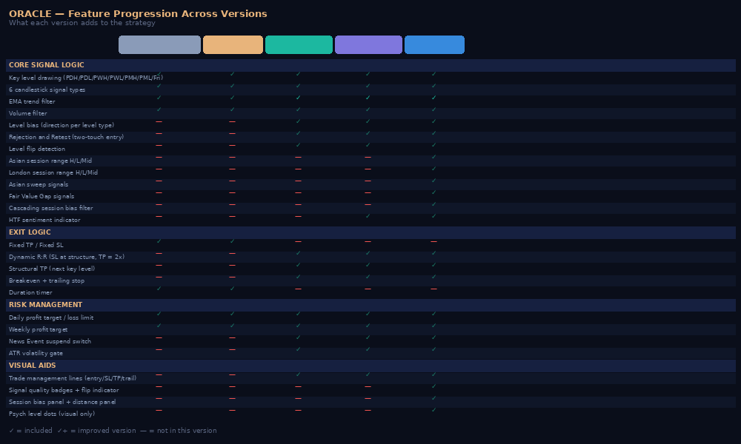

5.2 Three Session Strategy merge
v1.7 merges the Oracle level-rejection framework with the NQ Three Session Strategy v3 — a separate Pine Script v6 strategy covering Asian, London and NY session ranges. The merged strategy combines Oracle's structural level logic with the Three Session's session range intelligence.

Feature | Oracle v1.6 brings | Three Session v3 brings
Structural levels | PDH/PDL/PWH/PWL/PMH/PML/Fri Close with bias/flip | Asian High/Low/Mid, London High/Low/Mid
Signal types | 6 candlestick patterns + rejection/retest | Liquidity sweep signals, Fair Value Gaps
Session intelligence | EMA filter | Cascading Asian→London→NY bias filter
Entry confirmation | Two-touch retest model | Sweep conflict guard, FVG re-entry
Exit logic | Structural SL/TP, breakeven, trail | 2:1 R:R fixed ratio (adopted into dynamic model)
Risk management | Daily/weekly P&L limits, news suspend, ATR gate | Max trades per day
Visual aids | Trade management lines, EMA arrow | Session background shading, psych level dots

5.3 v1.7 prerequisites — all five required
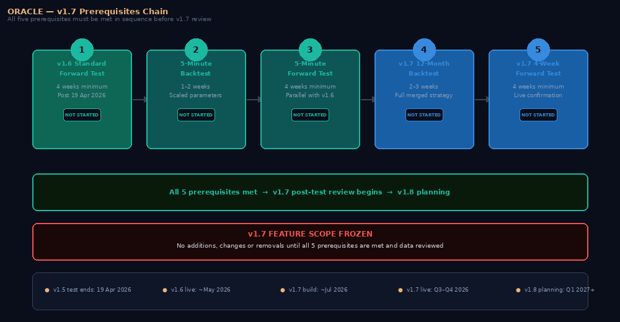

# | Prerequisite | Minimum duration | Purpose
1 | v1.6 Standard live and stable | 4 weeks minimum | Confirms the v1.6 foundation is solid before building v1.7 on top of it
2 | 5-minute backtest with scaled parameters | 1–2 weeks | Validates that Oracle's signals work correctly with 5-min timeframe scaling
3 | 5-minute forward test | 4 weeks minimum | Live confirmation of 5-min behaviour in real market conditions
4 | v1.7 12-month backtest | 2–3 weeks | Validates the merged Three Session strategy performance over a full year
5 | v1.7 4-week forward test | 4 weeks minimum | Live confirmation before any post-release changes are considered

6 v1.8 Post-Test Review
v1.8  Q1 2027 (est.)  FUTURE | First opportunity to add, change or remove v1.7 features — driven entirely by live data  Scripts: Oracle_Basic_v1.8 · Oracle_Pro_v1.8 · Oracle_Master_v1.8

v1.8 does not exist yet as a defined feature set. It will be planned only after the following data is collected and reviewed:

- v1.7 4-week forward test CSV — Which visual aids are genuinely useful vs which create noise. How the session bias cascade performs in live conditions. Actual R:R profile with structural exits.
- v1.7 12-month backtest — Whether the merged Three Session strategy improves or changes the overall performance profile compared to Oracle v1.6.
- Live trading feedback — From all users of the strategy. Which features are confusing, which are essential, which could be simplified.

THE DISCIPLINE | v1.8 planning begins only after all v1.7 prerequisites are met and data has been reviewed. This is the same discipline applied at every version transition. It is what prevents the strategy becoming overloaded with features that have not been tested.

7 Estimated Timeline
All dates are estimates. Each phase can only begin when the preceding phase's prerequisites are confirmed. Actual dates will depend on market conditions, performance data, and build complexity.

Milestone | Estimated date | Trigger | Status
v1.5 forward test ends | 19 Apr 2026 | 4 weeks from 22 Mar 2026 | ACTIVE
v1.6 Standard build complete | ~3 May 2026 | 4-week CSV delivered | PENDING
v1.6 Standard goes live | ~5 May 2026 | Build and backtest complete | PENDING
v1.6 Sentiment build | ~1 Jun 2026 | v1.6 Standard live 4 weeks | PENDING
5-min backtest begins | ~15 Jun 2026 | v1.6 Sentiment stable | PENDING
5-min forward test begins | ~1 Jul 2026 | 5-min backtest complete | PENDING
v1.7 build begins | ~1 Aug 2026 | All 5-min prerequisites met | PENDING
v1.7 goes live | ~Sep–Oct 2026 | Build, backtest, deploy | PENDING
v1.7 forward test ends | ~Nov 2026 | 4 weeks from go-live | PENDING
v1.8 planning begins | ~Jan 2027 | v1.7 data reviewed | FUTURE

8 Governance — How Decisions Are Made

8.1 The evidence-first principle
Every change to Oracle at every version must be traceable to a specific data point from live trading or backtest results. Features are not added because they seem like a good idea — they are added because evidence shows they will improve performance.

8.2 Standing instructions
- User Guide update: The Oracle Strategy User Guide is updated with every version release, settings change, and new pattern identified during live testing.
- Development Tracker update: The Oracle Development Tracker (Excel workbook) is updated at every version release with the full changelog, backtest results, forward test log, and settings at release.
- No code changes during forward tests: Once a version is in its 4-week forward test, no code changes are made regardless of issues observed. Issues are logged for the next version.
- Version backups: Every version is saved as individual .pine files for Basic, Pro and Master — 18 files minimum per major version. Archived in Oracle_Version_Backups.zip.

8.3 Feature freeze policy
v1.7 feature scope is frozen as of April 2026. This decision was made to prevent the flagship version from being overloaded with untested features. The Three Session strategy merge alone represents a substantial increase in complexity. Adding further features before live testing would risk creating a strategy that is difficult to debug, optimise and explain to users.

v1.8 is the first opportunity to modify v1.7's feature set. That modification will be driven entirely by what the v1.7 live data shows — not by speculation about what might improve things.

Oracle Development Roadmap · April 2026 · NQ/MNQ Futures · TradingView Pine Script v5
This roadmap is a living document updated at each version milestone. Current version: v1.5 (Live). Next milestone: v1.6 Standard post 19 April 2026.

